Navigating Academia: An Australian Association for the Studies of Religion HDR Event
Wednesday 4th of December, 2019

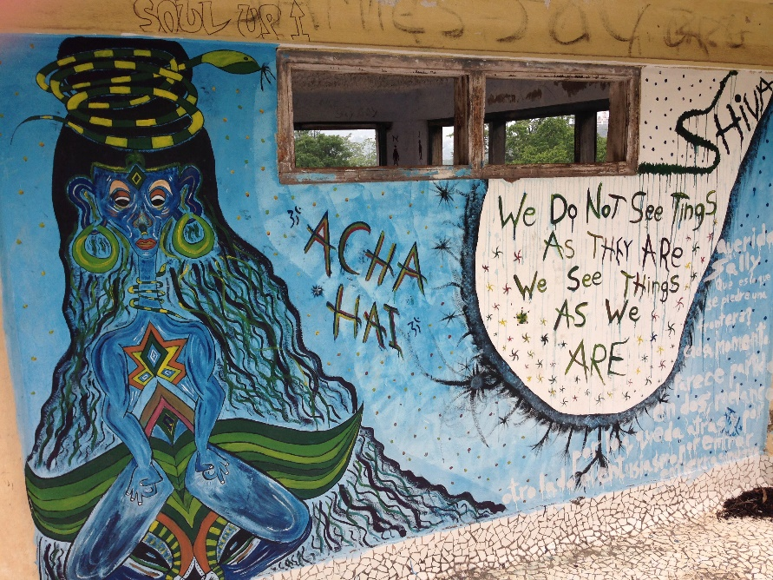

What:
This workshop is both a social and professional event, aimed at creating an environment for learning and networking for HDR and early career scholars. The speakers are all at different points of their careers and will offer advice on themes of mental health, scholarship tips and how to actually submit your PhD. The second component of the workshop will be a 3 minute thesis delivery followed by a discussion allowing your peers to get to know your research ideas and offer feedback. Finally, the event will finish with drinks and dinner at a nearby restaurant. This event is open to all early career academics and HDR students attending the AASR conference. We hope to see you there!

Where:
Room X301, 3rd Floor, NeWspace City Campus, University of Newcastle

When:
2:00 - 2:30 – Dr Zoe Alderton: (School of Economics, University of Sydney) will provide constructive solutions to common mental health and motivation problems faced by HDR students - based on the upcoming guide book The Way of the Scholar. Audience members will also get a chance to discuss their thoughts in a safe and supportive environment.
2:30 - 3:00 – Dr Christopher Hartney: (University of Sydney) will examine strategies I have used (and some of my failures) as a supervisor helping students remain aware of the psychological damage that can come from undertaking research with violent and confronting content.
3:00 - 3:30 – Snacks/Break
3:30 - 4:00 – Dan Towers: (PhD Candidate, University of Sydney) will explore submitting your thesis and some handy tips on making the most of your PhD.
4:00 - 5:00 – 3minute Thesis workshop
5:00 - 6:30 – Dinner and drinks at Finnigan’s Jamaican Hotel (Vg & GF available)

Please signup when registering for the conference.
Any Questions please contact AASR HDR Rep Tara BM Smith (tsmi5200@uni.sydney.edu.au).

